AM000-Asia-China-Tang Five Animals and Grapes-618-907 CE

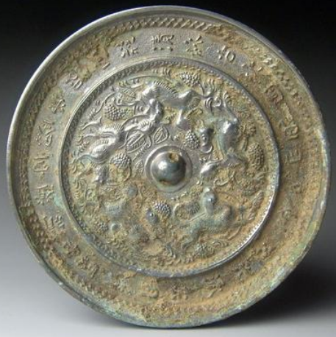

Bronze Mirror, Tang Dynasty (618-907, early 7th cent.) -

Five running animals and grapes mirror, 5.l in., 398 gm.

The flowing motion of the five animals running counter-clockwise around a central boss provides a sense of continuous motion. The nature of these animals may be partly mythological and partly real.

The outer band contains a poem in quatrain (which is similar to another mirror of this design, which reads:

I received a gift: the mirror of the King of Qin.

For this, I would have paid willingly a thousand teels of silver.

In no way would I use it to unveil your hidden desires.

Verily, I wish to lay bare my own heart (Chou 2000:62-63)."

The legend of the King of Qin's mirror was that it analyzed the moral worth of those who stood before it, while who stood before it , while poet in the case of this mirror wishes only to reveal the innermost thoughts of his own soul and therefore draws a distinction between his mirror and that of King Qin.

This mirror may have a similar poem on its outer band. [Needs expert translation.]

Iconographically, one might associate the structure and imagery of this mirror with those of the "Lion and Grapes" design. If so, then this mirror would be placed in the early Tang period. It would also the view that grapes were newly introduced from Xinjiang in western China so that the grape imagery was dependent on this cross-cultural connection in the later Sui Dynasty (589-618 CE).

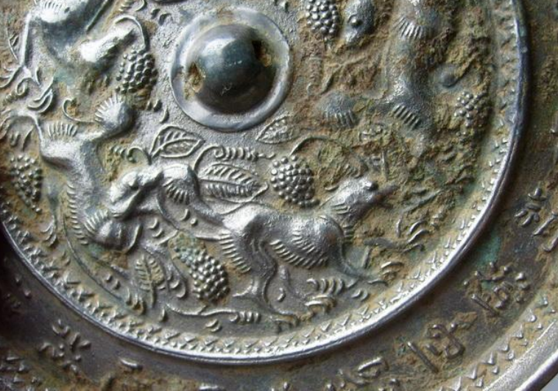

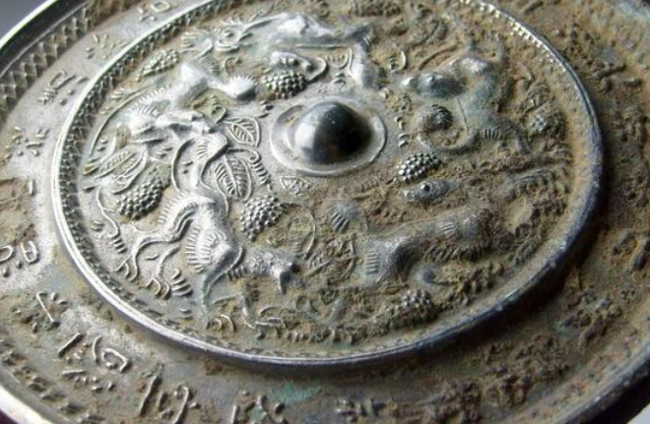

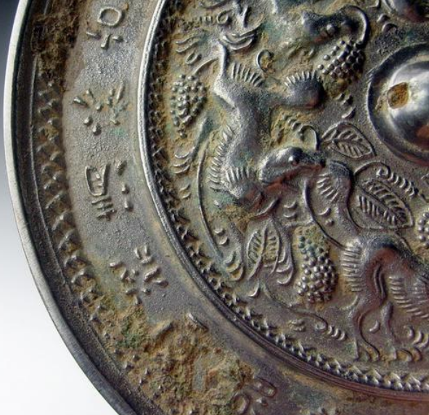

# Tang inscriptions (Liu Guang Shu Yue) bronze mirror